**Group Members:**

Omer Muhammadi FA22-BDS-029

Abdullah Amir FA22-BDS-002

Iqra Add your Regno

**Submitted to: Dr. Muhammad Manzoor Ilahi Tamimy**

December 15, 2023

**Project Documentation**

Programming Fundamentals

**Cinema Management System**

**Project Documentation**

**Table of Contents**

1. [**Introduction**](https://chat.openai.com/c/8843a0c7-f34b-40d0-bfa8-974ca0457991#introduction)
2. [**Libraries Used**](https://chat.openai.com/c/8843a0c7-f34b-40d0-bfa8-974ca0457991#libraries-used)
3. [**Project Structure**](https://chat.openai.com/c/8843a0c7-f34b-40d0-bfa8-974ca0457991#project-structure)
4. [**Key Features**](https://chat.openai.com/c/8843a0c7-f34b-40d0-bfa8-974ca0457991#key-features)
5. [**Code Snippets**](https://chat.openai.com/c/8843a0c7-f34b-40d0-bfa8-974ca0457991#code-snippets)
6. [**How the Project Works**](https://chat.openai.com/c/8843a0c7-f34b-40d0-bfa8-974ca0457991#how-the-project-works)
7. [**Future Improvements**](https://chat.openai.com/c/8843a0c7-f34b-40d0-bfa8-974ca0457991#future-improvements)

**1. Introduction**

The Cinema Management System, built with Java, makes cinema tasks easy. You can check out movies, buy tickets with flexible prices, order snacks, and share your thoughts. It's a simple and helpful tool for both cinema staff and customers, making the whole movie experience smooth and enjoyable.

**2. Libraries Used**

* javax.swing: Graphical user interface creation.
* java.awt: Handling basic window components.
* java.awt.event: Managing user input events.
* java.io: Input/output operations.
* java.net: Working with URIs.
* java.util: Miscellaneous utility classes.
* java.util.List: Handling lists of objects.

**3. Project Structure**

The project comprises several classes:

* **Movie:** Represents a movie with various attributes.
* **Cinema Management System:** The main class that initializes the application.
* **AdminDashboard:** Handles administrative functionalities.Providing features like viewing statistics, feedback, and staff members.
* **CustomerSection:** Manages customer-related action,including ordering food, booking tickets, providing feedback, and viewing recommendations.
* **StaffMember:** Represents a staff member with details like name, work, and monthly salary.

**4. Key Features**

* Movie Display: Lists movies with details such as title, genre, duration, and rating. It ensures an organized and visually appealing representation of the available movies.
* Admin Dashboard: Allows administrators to view statistics, feedback, and manage staff members. This dashboard serves as a control center for administrative tasks within the cinema management system.
* Customer Section: Provides customers with options to order food, book tickets, and provide feedback. . This section aims to make the customer's interaction with the cinema management system user-friendly and efficient.
* Main class representing the entire cinema management system. Manages movies, food menu, staff members, and movie feedback. Integrates an Admin Dashboard and a Customer Section. It manages crucial aspects such as movies, the food menu, staff members, and movie feedback. Additionally, it integrates two significant components: the Admin Dashboard and the Customer Section.

**5. Code Snippets**

**Movie Class:**

**Cinema Management System Class:**

**Admin Dashboard Class:**

**Customer Section Class:**

**Food Menue:**

**Admin Login:**

**Movie Recommendation:**

**Movies statistics with random data:**

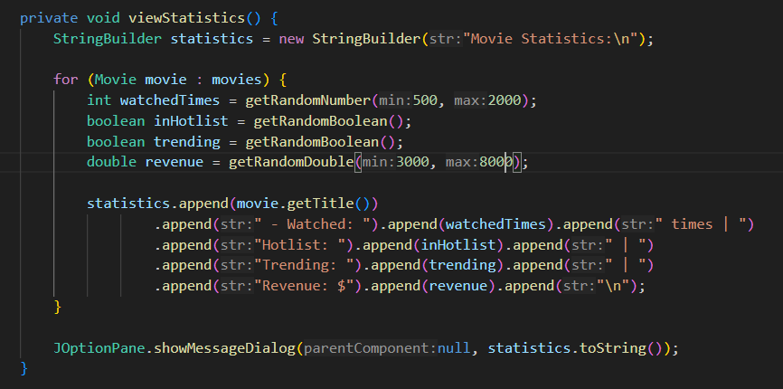

**6. How the Project Works**

**6.1 Movie Display**

When you open the app, you'll see a list of movies with details like title, genre, duration, and ratings. Scroll through to explore.

**6.2 Admin Dashboard**

**6.2.1 Accessing Admin Features**

Click "Admin Login" and enter credentials to unlock special admin features.

**6.2.2 Admin Features**

* View Statistics: Check movie stats like views, popularity, and dummy revenue data.
* View Feedback: Read customer feedback for each movie.
* View Staff Members: See staff names, roles, and monthly salaries.

**6.3 Customer Section**

**6.3.1 Accessing Customer Features**

Click "Customer Section" to access customer features.

**6.3.2 Customer Features**

* Order Food: Choose food items, and get a confirmation.
* Book Tickets: Pick a movie, select ticket quantity, and get a bill with random prices and 17% GST.
* Provide Feedback: Share your thoughts on a movie.
* View Recommendations: Check out recommended movies like "Sholay," "Barbie," and "Tarzan" (dummy data).

**6.4 Staff Members**

In the Admin Dashboard, find the "View Staff Members" feature to see staff details.

**6.5 Cinema Management System Flow**

Navigate through movies, admin features, customer actions, and staff management easily. The user-friendly interface ensures a smooth experience for admins and customers.

**\*\*\*\*\*\*\*\*\*\*\*\*\*\*\*\*\*\*\*\*\*\*\*\*\*\*\*\*\*\*\*\***